Pumpkin Decorating Contest!
Hello NCES Stars!! We are so excited to announce that we will have a Pumpkin Book Decorating Contest for the school this year. Pumpkins are to be decorated to look like your student’s favorite book character!
Guidelines are below:
- Choose a character from a book that you have read or want to read. It does not have to be a book from the NCES library.
- You may use real pumpkins (do not carve), gourds, or fake pumpkins! Fake pumpkins are a great decoration to use for the fall season (If pumpkins start to go bad they will be thrown out)
- Your disguised pumpkin should have distinctive traits from the literary character and should be easily identifiable.
- NO scary pumpkins!!(this includes anything gory, fake blood, etc….)
- Use EVERYDAY materials to bring your Literary Pumpkin “to life”. (Examples: acrylic paint, cotton, yarn, markers, google eyes, pipe cleaners, etc.….)
- Please do not carve pumpkins or poke holes in the pumpkin (due to rotting or smell).
- Add a label showing the character’s name and book title to be displayed with the pumpkin. Please have the students name, teacher, and grade level on the paper
- Use your imagination and HAVE FUN!!!
- Pumpkins need to be picked up October 28th or they will be sent home with students on the 31st.
Literary Pumpkins can be brought to school starting October 19th!
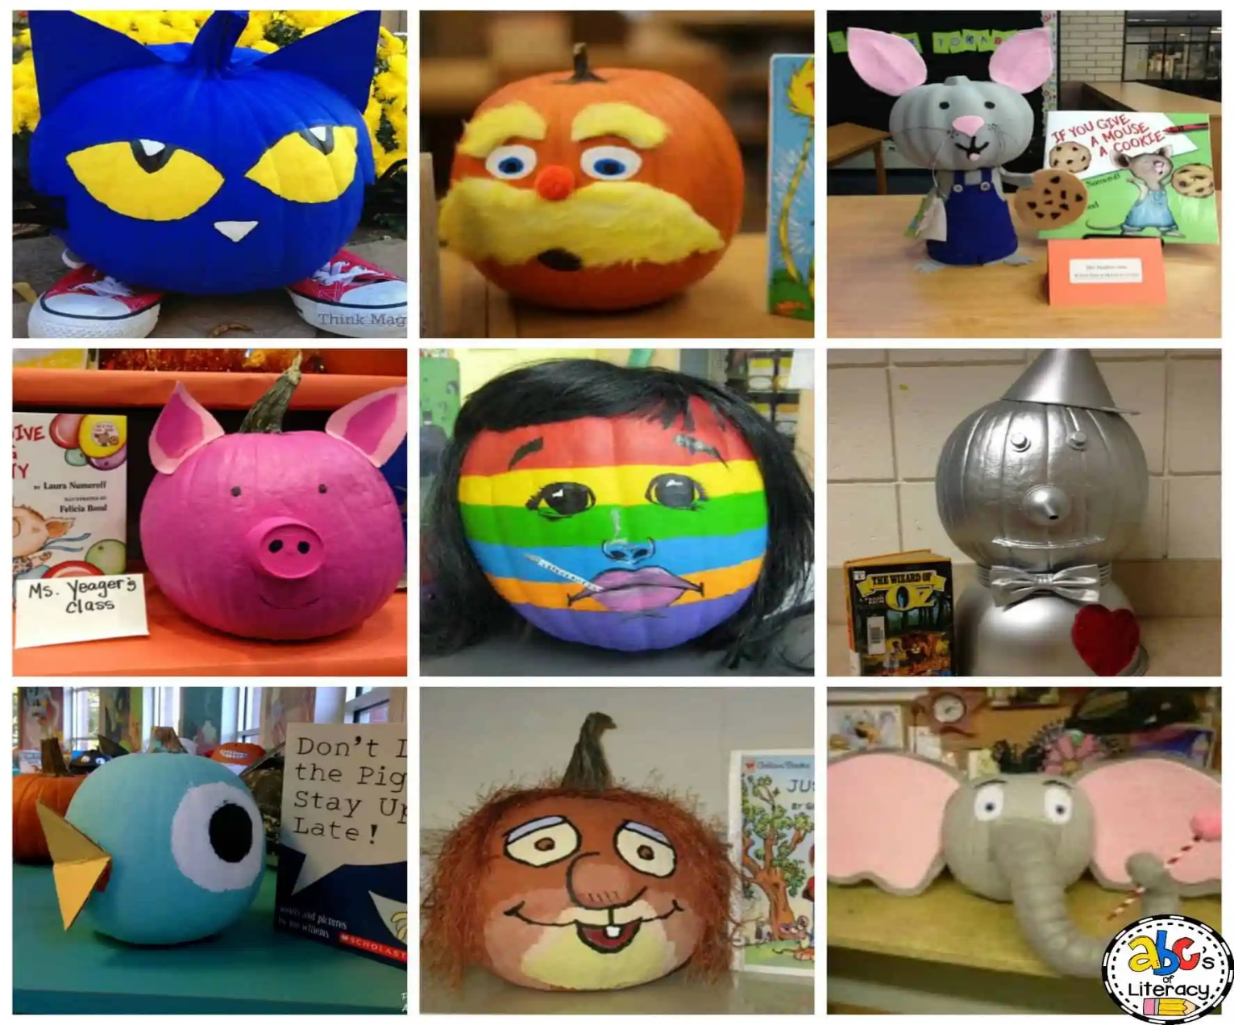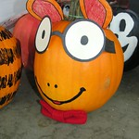Here are a few examples of Literary Pumpkins!! You do not have to bring in the book, but you may choose to do so. You must have your name, book title, and students name on the paper to be displayed with your pumpkin!
This Photo by Unknown Author is licensed under CC BY-SA-NC

